**Project Plan**

***TickieSystem***

*Invividual Project-*

*Semester III*

|  |
| --- |
| **Date : 08.10.2020** |
| **Version : 1.0** |
| **State : Unfinished** |
| **Author : Aleksandar G** |

#### Version history

|  |  |  |  |  |
| --- | --- | --- | --- | --- |
| **Version** | **Date** | **Author(s)** | **Changes** | **State** |
| V 1.0 | **08.10.2020** | **Aleksandar G** |  | **Unfinished** |
|  |  |  |  |  |
|  |  |  |  |  |

Contents

1. Project assignment 4

1.1 Context 4

1.2 Goal of the project 4

1.3 Scope and preconditions 4

1.4 Strategy 4

1.5 Research questions 4

1.6 End products 4

2. Project Organisation 6

2.1 Stakeholders and team members 6

2.2 Communication 6

3. Activities and time plan 7

3.1 Phases of the project 7

3.2 Time plan and milestones 7

4. Testing strategy and configuration management 8

4.1 Testing strategy 8

4.2 Test environment and required resources 8

4.3 Configuration management 8

5. Finances and Risk 9

5.1 Project budget 9

5.2 Risk and mitigation 9

# Architectural Design

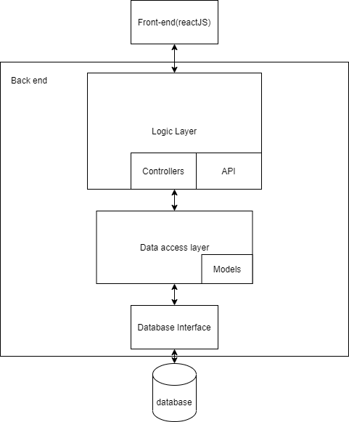

# Database Design

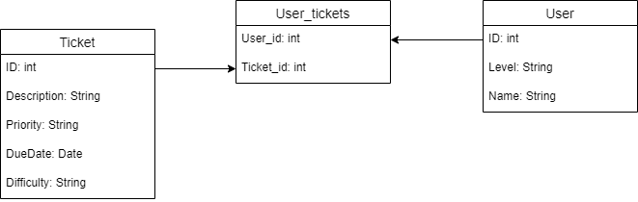

# Design Desicions

## Back-end Framework

I chose Spring boot over jersey bacause the documentation of Spring boot is way better than the documentation of jersey and moreover, Spring-boot in the most famous back end java framework ,therefore, it has a lot more resources and tutorials online.

## Front-end Framework

I chose React.js as my front end framework because it is again the most wide spread front end framework out there. It is not that hard to go into the performace in good and the syntax is elegant. There ar a lot of qualoty tutorials online for it and the documentation is ok.